# Development, Deployment and Testing Environment.

## Development Environment

The PHP based Hospital Management System application was developed using the following software tools and libraries:

**1. Database System:**

MariaDB Server: Version 10.4.14

**2. Web Server:**

Apache: Version 2.4.46

**3. Serverside Scripting:**

PHP: Version 7.4.14

4. **Frontend Libraries and Frameworks:**

HTML5 and CSS

Bootstrap: Version 4.6

jQuery: Version 3.2.1

## Setup Instructions

**Database , Web Server and PHP**

The following set up instructions show how to set up the Lampp stack which comprises of

Apache web server, Mysql database , PHP and Perl, and importing the database script to the mySQL server.

### Installing XAMPP on Linux:

**1. Downloading XAMPP:**

Visit the official XAMPP website [lampp download website](https://sourceforge.net/projects/xampp/files/XAMPP Linux/7.4.14/)

[https://sourceforge.net/projects/xampp/files/XAMPP%20Linux/7.4.14/](https://sourceforge.net/projects/xampp/files/XAMPP Linux/7.4.14/) and download the Linux version of XAMPP.

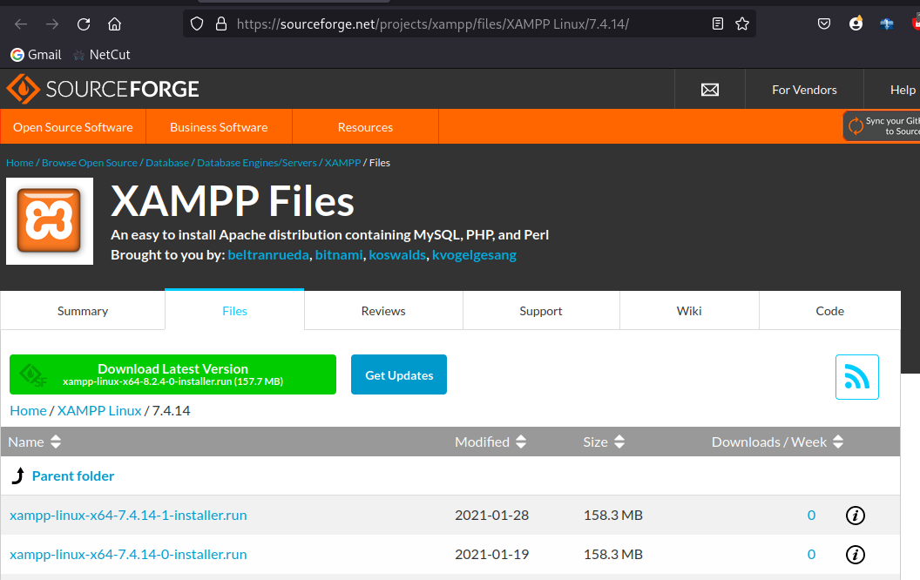

**2. Make the Installer Executable:**

Once the download is complete, navigate to the directory where the ***xampp-linux-x64-7.4.14-0-installer.run*** file is located, lets say the /opt folder , in a new terminal window run the command:.

*cd /opt*

Make the installer executable by running the following command on the terminal window

*sudo chmod +x xampp-linux-x64-7.4.14-0-installer.run*

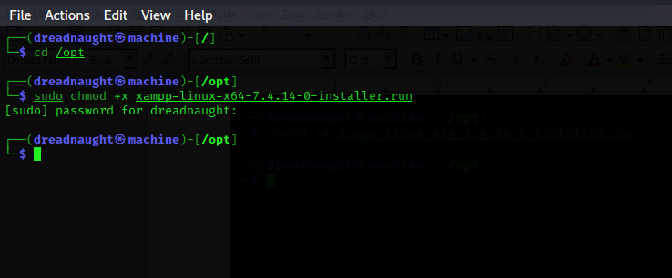

**3. Run the Installer:**

Start the XAMPP installation process by running:

*sudo ./xampp-linux-x64-7.4.14-0-installer.run*

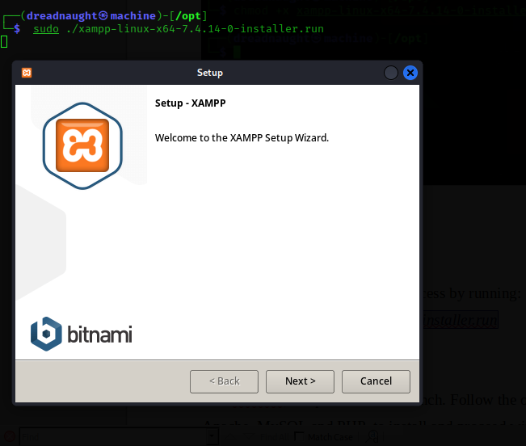

**4. Follow the On-Screen Installation Wizard:**

The XAMPP setup wizard will launch. Follow the on-screen instructions and choose components Apache, MySQL and PHP to install and proceed with the installation .

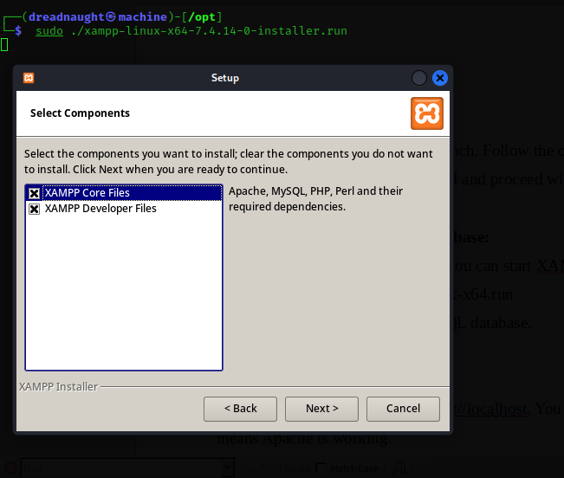

**5. Start Apache and MySQL database:**

After a successful installation, XAMPP is started using the command:

*cd /opt/lampp/ && sudo ./manager-linux-x64.run*

and start apache web server and MySQL database.

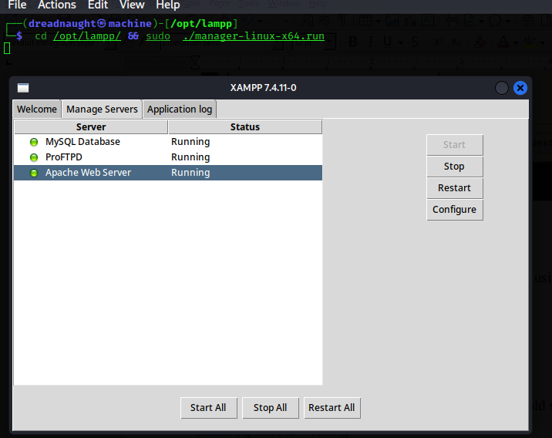

**6. Test Your Installation:**

Open a web browser and visit [http://localhost](http://localhost/). You should see the XAMPP welcome page, which means Apache is working.

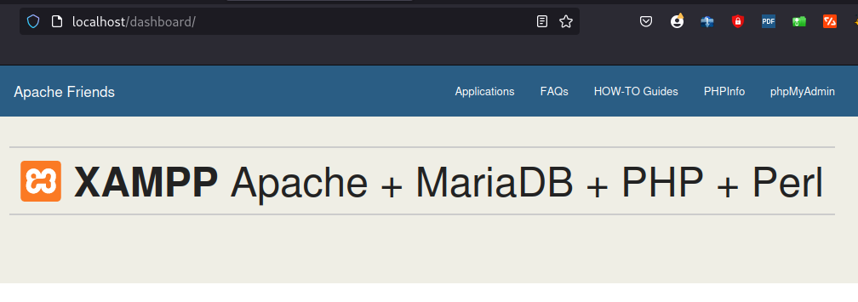

Click on the phpMyAdmin link on the top right corner to ensure that the MySQL database is working.

This will have installed PHP 7.4.14 Apache Apache: Version 2.4.46 and MariaDB Server: Version 10.4.14

The frontend libraries come bundled up with the application, therefore no need to manually set them up.

# 2. Application Deployment.

After a successful installation of the lampp stack, we have to move our zipped application to the ***/opt/lampp/htdocs*** folder and extract it to make it accessible on the browser.

**1. Importing the database script.**

On your browser, visit <http://localhost/phpmyadmin/server_import.php> and click on the browse button

and select the database script located in

***/opt/lampp/htdocs/hospital/Important/hms.sql***

*and click the go button at the bottom of the page.*

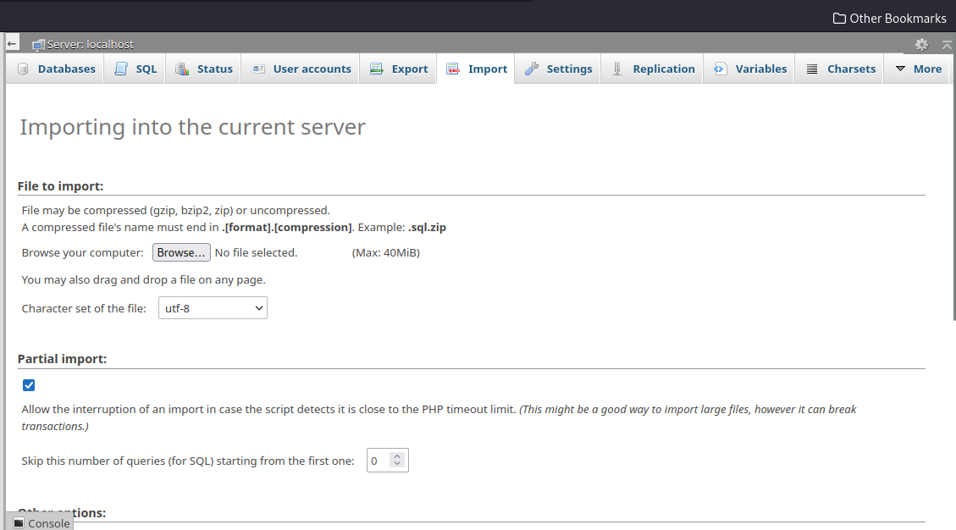

This will import the hospital management system into the database server .

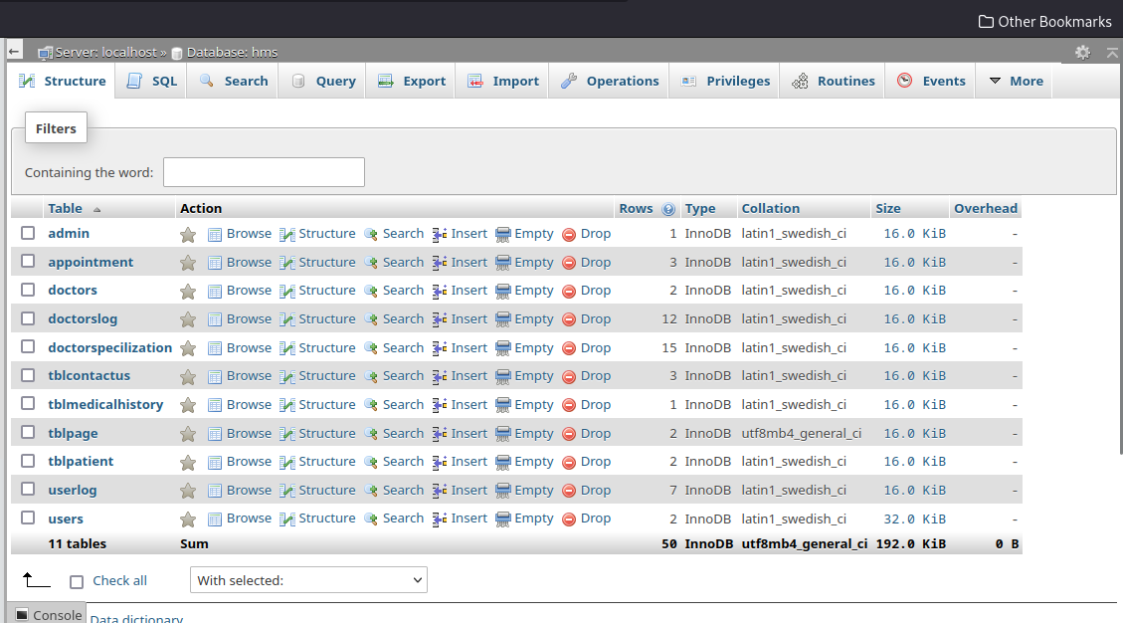

**2. Running the application on a browser.**

We have successfully imported the database script. It is time now to rin our application on the browser by visiting <http://localhost/hospital/>

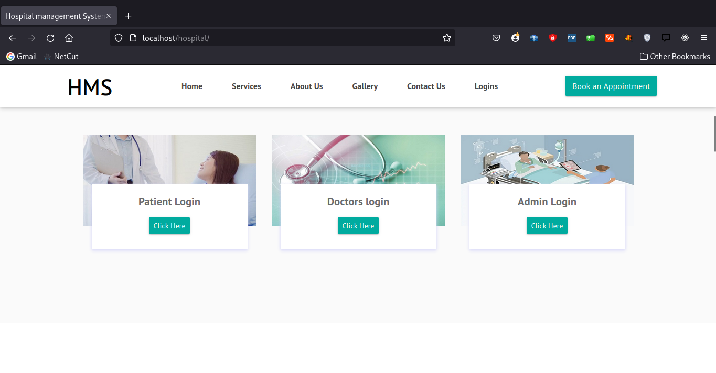

The user can log in to the system as a patient, doctor or an admin using the credentials below.

### Admin login Credentials:

**Username** : admin

**Password**: Test@12345

### Patient Login Credentials:

**Username**: [light@gmail.com](mailto:light@gmail.com)

**Password**: Test@123

**Username:** mercy@gmail.com

**Password:** [Test@123](mailto:Test@123)

### **Doctor Login Credentials:**

**Username:** [doctor@gmail.com](mailto:doctor@gmail.com)

**Password:** Test@123

**Username:** [doctor1@gmail.com](mailto:doctor1@gmail.com)

**Password:** Test@123

# 3. Application Testing Environment.

The testing environment used was the same as the environment described above. This environment comprised of:

**1. Database System:**

MariaDB Server: Version 10.4.14

**2. Web Server:**

Apache: Version 2.4.46

**3. Serverside Scripting:**

PHP: Version 7.4.1